1. Project Title: AI-Powered Image Stylization and Cartoonization Platform
2. Project Statement and Outcomes:
The AI-Powered Image Stylization and Cartoonization Platform project aims to develop an interactive application that converts real-world images into various cartoon-style effects using OpenCV. This project involves implementing advanced image processing techniques such as edge detection, bilateral filtering, color quantization, and stylization filters to achieve different visual transformations like cartoon, sketch, and pencil color effects.
The outcome will be a user-friendly Streamlit-based web application where users can upload images and instantly transform them into selected cartoon styles. The application will include features like filter selection and side-by-side image comparison (original vs cartoonized) for better visualization. It will cater to general users, artists, and digital content creators. The project will conclude with thorough testing to ensure performance, usability, and reliability, supported by well-documented reports for future improvements.

3. Modules to be Implemented:
- User Authentication & Registration
- Image Processing with OpenCV
- UI Development & Payments Integration
- Testing, Review, and Documentation
4. Week-wise Module Implementation and High-Level Requirements:
Week 1-2: User Authentication & Registration
- Develop a system where users can sign up, log in, and manage their accounts securely.
- Structure the database to store user profiles, log in details, and access rights efficiently.
- Implement input validation (e.g., password strength, email format) and error handling for a smooth user experience.
Week 3-4: Image Processing with OpenCV
- Implement image processing techniques for cartoonization using OpenCV.
- Apply edge detection, bilateral filtering, and color quantization.
- Optimize the processing pipeline for different image types and sizes.
- Add multiple cartoon styles: Classic Cartoon, Sketch, and Pencil Color effects.
- Add an image comparison feature to show original vs cartoonized versions side-by-side.
- Ensure efficient and high-quality transformation of images.
- Allow users to download the cartoonized image before proceeding to the download/payment step.
Week 5-6: UI Development & Payments Integration
- Create an interactive and easy-to-use web interface for image upload, processing, and download.
- Design an intuitive UI layout that provides an easy-to-use experience.
- Make users pay before downloading the cartoonized image.
- Once the payment is successfully processed, the payment gateway will confirm the transaction. After validation, the user will be granted access to the image download.
Week 7-8: Testing, Review, and Documentation
- Perform extensive testing of the application to ensure accuracy and performance.
- Review and refine the UI to enhance usability and visual appeal.
- Document the entire process, including image processing techniques and UI functionalities.
- Prepare the final report and presentation, detailing the insights and potential applications of the project in digital art and entertainment.

5. Flow chart:
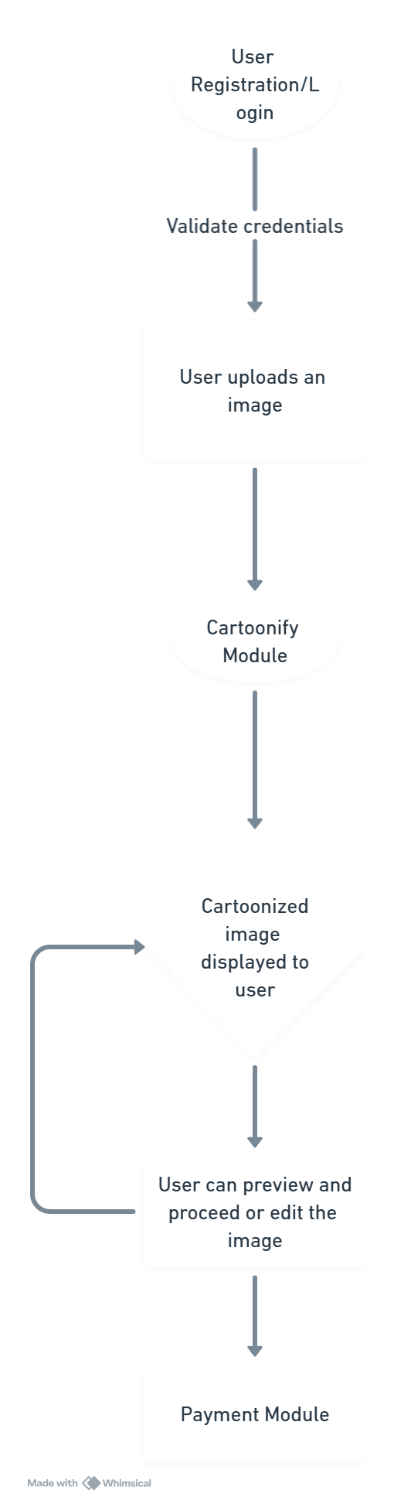

6. Sample Dashboard:
